Exercise 2- Data Visualization in Tableau

Question 1:

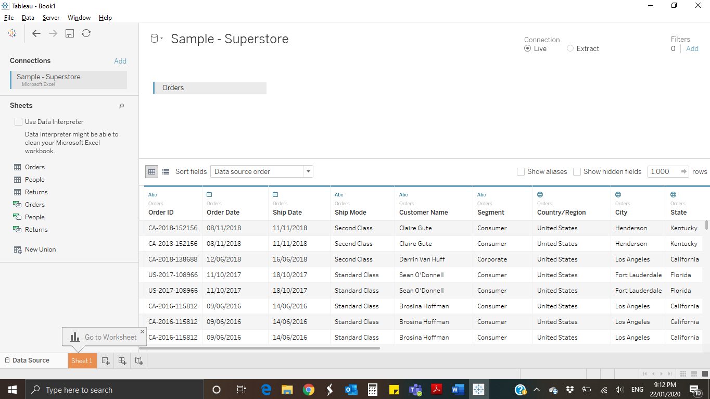

Question 2:

How many tables are there in the loaded dataset? A: **3**

Rows in Orders table? A: **9994 rows**

Columns in Orders Table? A: **21 columns**

Question 3:

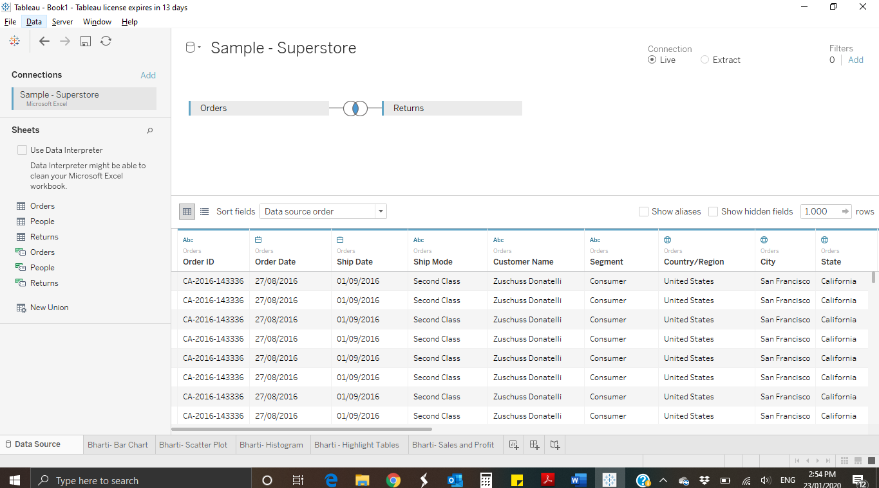

Inner Join of Orders and Returns on Order ID

Question 4:

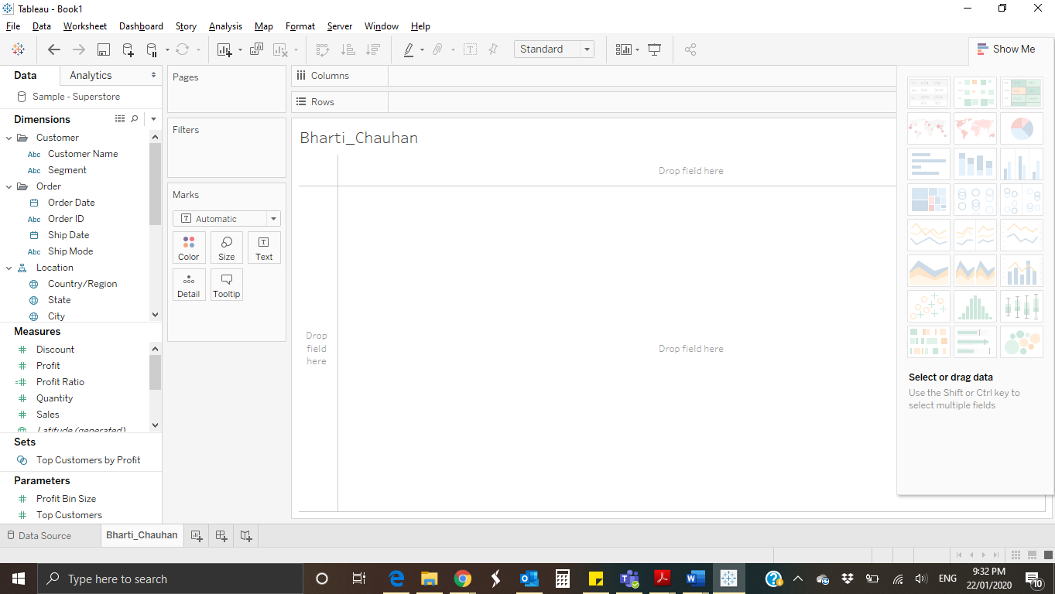

Question 5: Default Aggregation in Tableau is (b)**Sum**

Question 6:

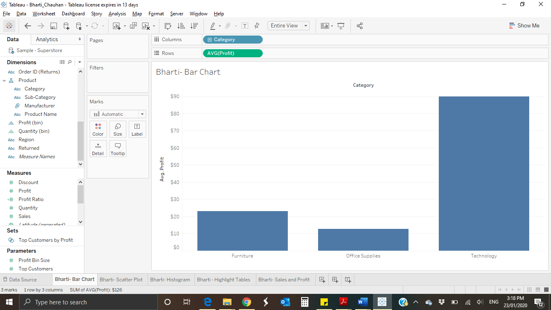

Question 7: Sum gave addition of profits according to which increasing order is Furniture being the least, then office supplies and then most profit from Technology. But the average of these products say that average profit of furniture is more than office supplies while Technology products give highest average profit.

Question 8:

Selecting only 2016, 2017 and 2018 results below:

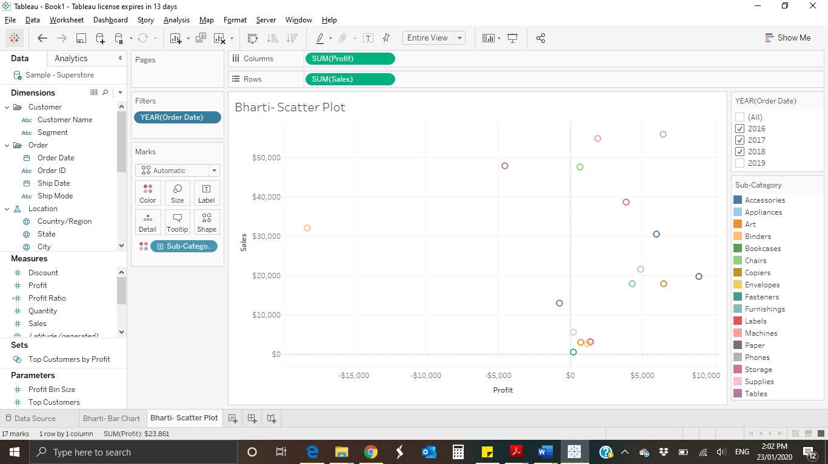

Question 9:

There are no Sales greater than $140,000 from 2016-2018.  
Subcategory having Sales greater than $140,000 from the year 2016-2019 is Sales.

There are no Profits greater than $10,000 from 2016-2018.  
Subcategory having Profit greater than $10,000 are Phones, Papers, Accessories, Appliances, Chairs, Copiers.

Question 10:

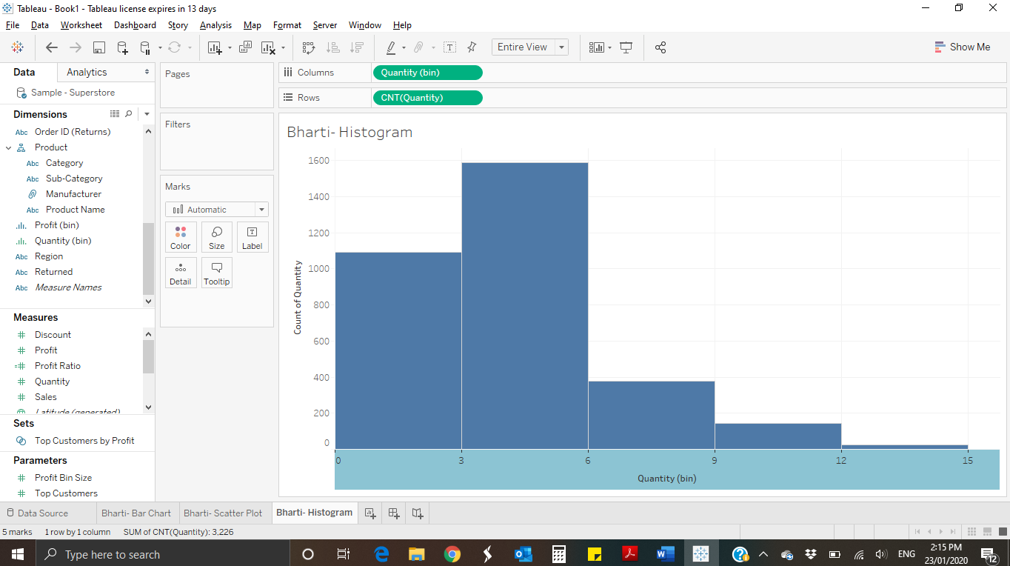

Question 11:

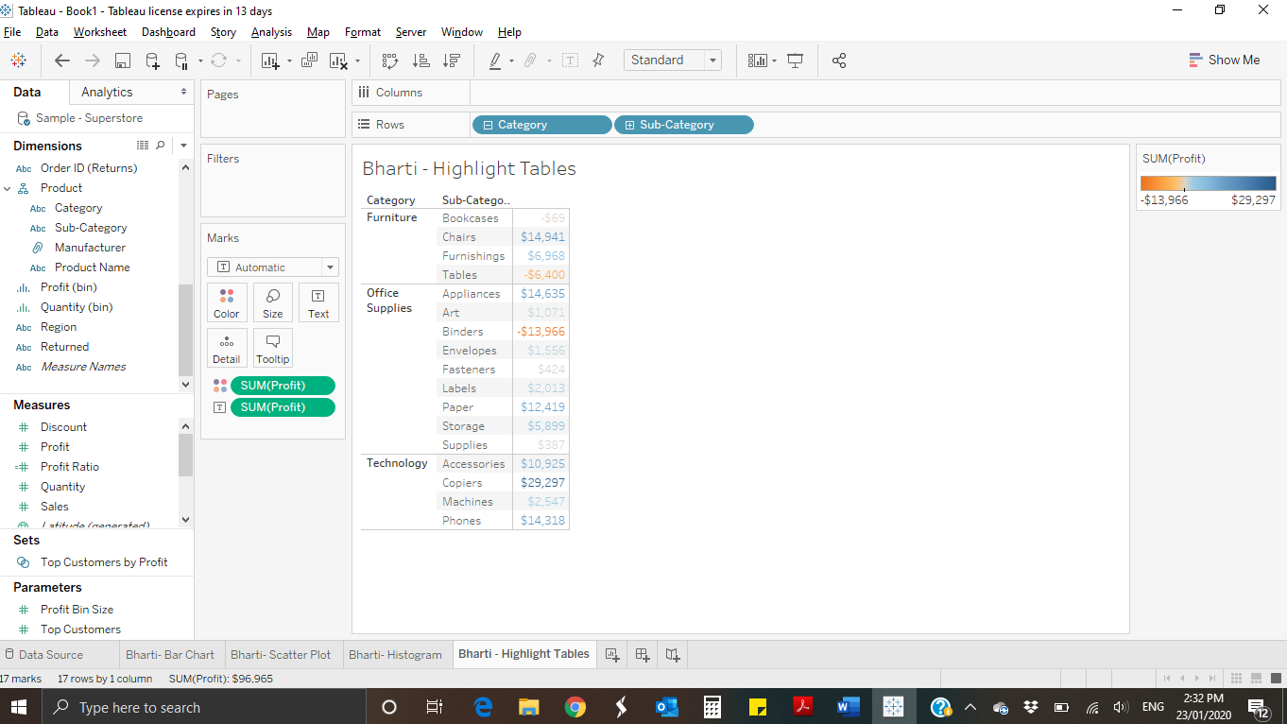

Question 12:

Subcategories making the most profit:

|  |  |
| --- | --- |
| Copiers | $29,297 |
| Chairs | $14,941 |
| Appliances | $14,635 |

Subcategories making the least profit:

|  |  |
| --- | --- |
| Bookcases | -$69 |
| Tables | -$6,400 |
| Binders | -$13,966 |

Question 13:

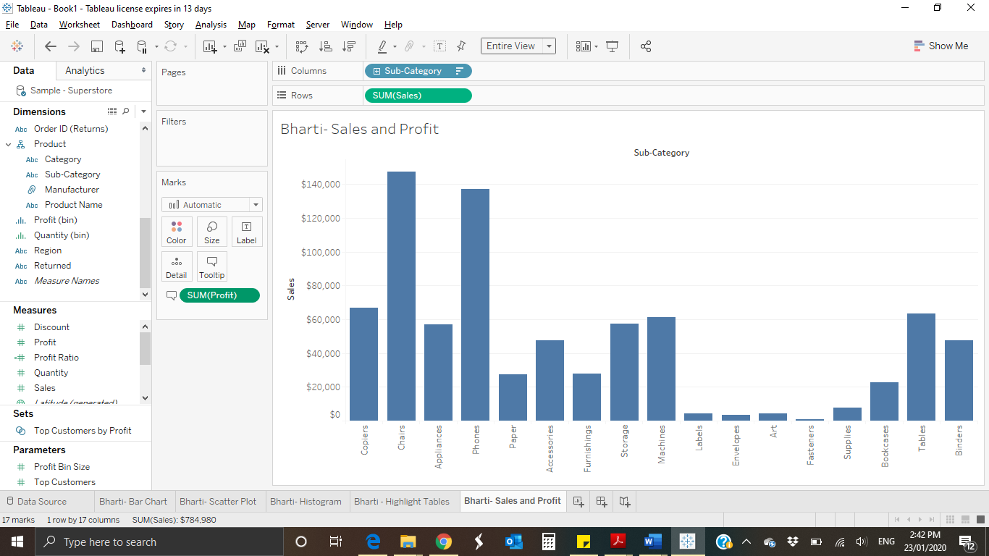

Question 14:

Subcategories making the highest sales:

|  |  |
| --- | --- |
| Copiers | $66,959 |
| Phones | $137,283 |
| Chairs | $147,380 |

Subcategories making the highest profit:

|  |  |
| --- | --- |
| Copiers | $29,297 |
| Chairs | $14,941 |
| Appliances | $14,635 |